**ITA0448 – STATISTICS WITH R PROGRAMMING FOR VECTORIZED EXPRESSIONS**

**SUBMITTED BY: DEVADARSHINI J REG NO: 192124092**

**DATE: 20/03/2023**

1. Write an R program to create a vector of a specified type and length. Create vector of numeric, complex, logical and character types of length 6 with your own examples. Print the vector, type, and length.

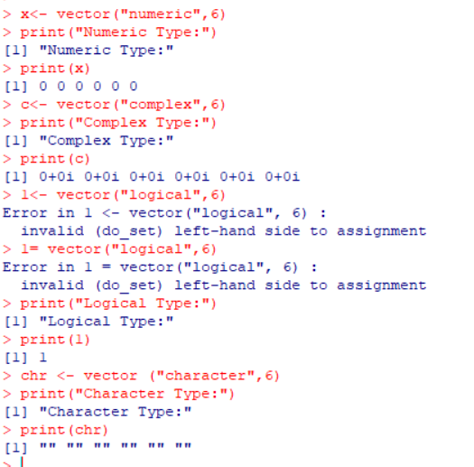

1. Write a R program to find Sum, Mean and Product of a Vector.

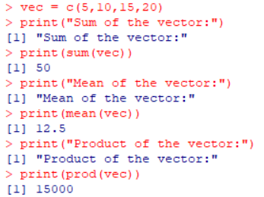

1. Write a R program to find the minimum and the maximum of a Vector

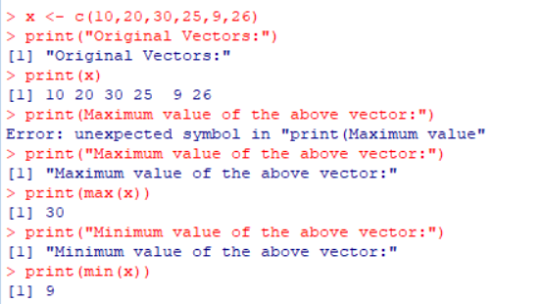

1. Write a R program to find second highest value in a given vector.

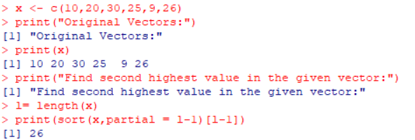

1. Write a R program to add a new item g4 = “C++” to a given list.

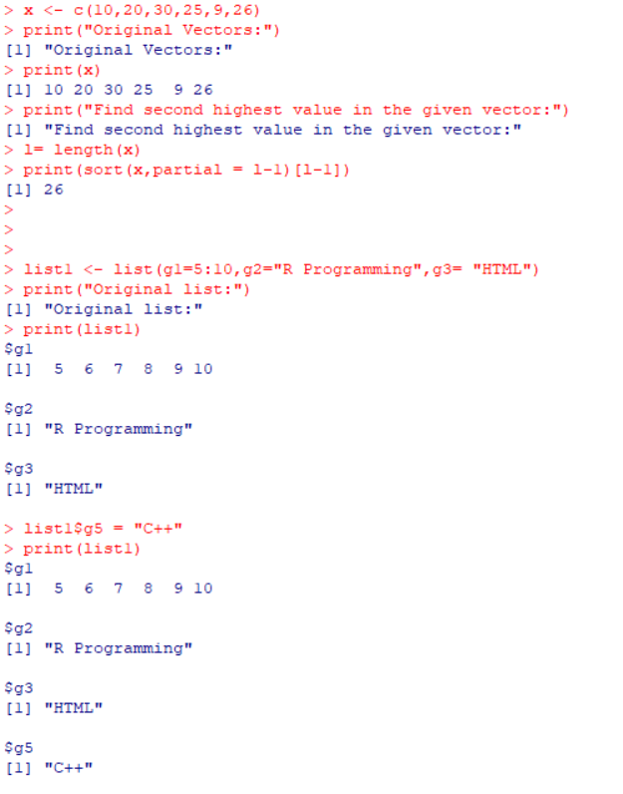

1. Write a R program to extract all elements except the third element of the first vector of a given list.

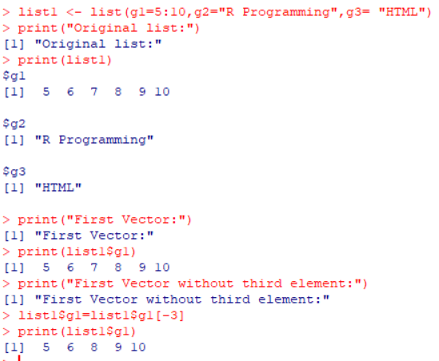

1. Write a R program to create an ordered factor from data consisting of the names of months.

